CALL FOR PAPERS
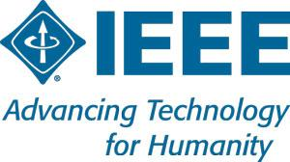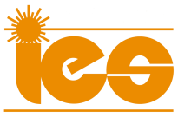

Special Session on Advanced Techniques for Smart Home and Prosumers

IECON 2018 - The 44th Annual Conference of the IEEE Industrial Electronics Society
October 21-23, 2018, Washington D.C, USA

ORGANIZED AND CO-CHAIRED BY

Dr. Djaffar OULD ABDESLAM djaffar.ould-abdeslam@uha.fr

Pr. Dirk Benyoucef
dirk.benyoucef@hs-furtwangen.de

Author’s schedule
- Deadline for submission of special session papers Ma y 1, 2018
- Notification of acceptance
July 15, 2018
- Deadline for submission of final manuscripts
August 1, 2018
TOPIC OF THE SPECIAL SESSION

This special session will be the opportunity to evaluate the latest identification, classification and control techniques for smart home and prosumers. The objective is the improvement of power quality, data analysis and cost savings. The influence of the wind turbine and PV systems on the power quality becomes so significant. An application of advanced techniques and artificial intelligence is a good opportunity for energy saving. Also, the solutions based on these techniques can improve the power quality issues and reduce the power consumption. It is therefore important to use the most effective identification and control methods in order to meet new requirements.

Topics of the Session
- Home Energy Management System
- Smart measures
- Energy efficiency
- Power quality improvement
- Analyzing the impact of prosumers in grids
- Mathematical and economic modelling of the Prosumer as an autonomous system
- Energy charring
- Improve the peak demand management
- Consumption reduction
- Modelling of electrical appliances, electrical systems and power plants
- Electrical signal measurements and analysis with advanced techniques

